1. Open slow PDF and select “Print”

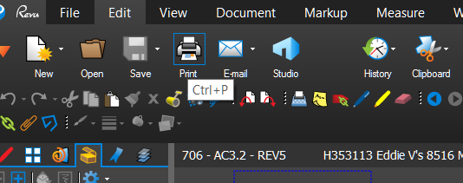

1. Select “Bluebeam PDF” as your printer

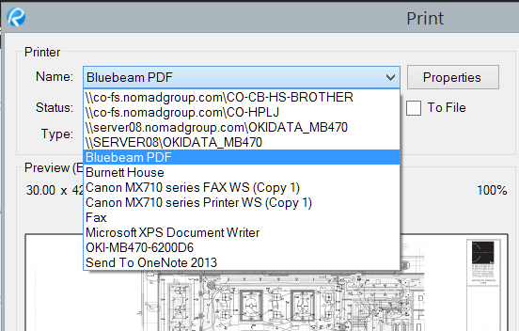

1. Press “Advanced” button on the bottom left of the print window

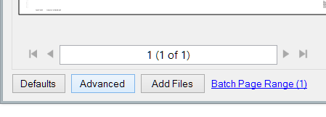

1. Select “Image” under print and press “OK”

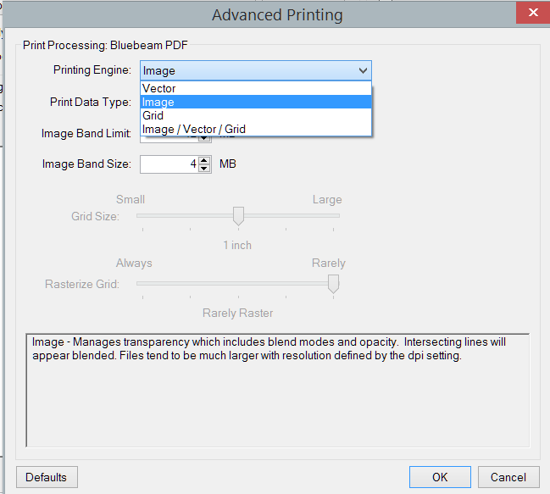

1. Press “Print” on the print options window

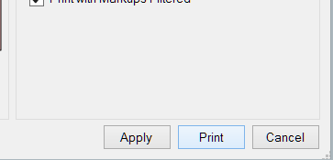

1. Bluebeam will then begin printing the new document. NOTE: This can take up to 25 minutes in my experience. If the document is very slow – it can take a very long time. Bluebeam will not be available during this time. It eats your memory and CPU also.

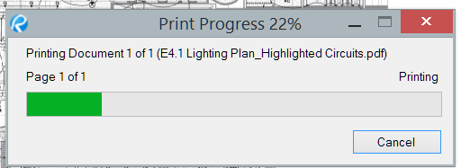

1. After printing – Bluebeam will prompt you for a place to save the file or will automatically save it in the designated folder according to how your Bluebeam Printer is setup. Once saved – Bluebeam will open the file and now you have a usable PDF.

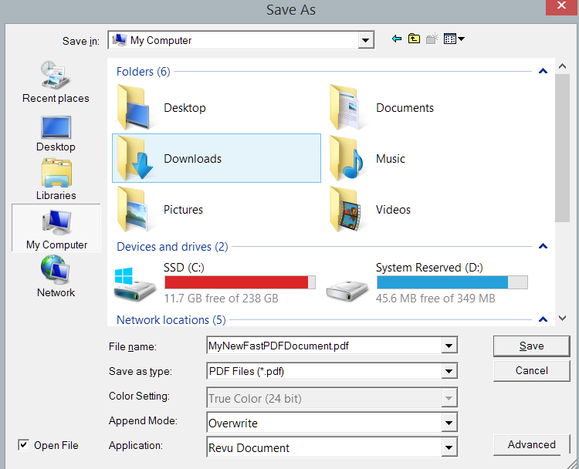

1. \*\*IF the file size after this process is larger than you would like and you can spare a small amount of image resolution. You can follow the below steps for reducing the file size.
2. With your image open – go to “Document” 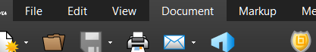
3. Under “Process” Select “Reduce File Size”

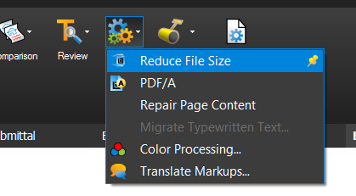

1. On the reduce file size menu you will be shown the current size of the file and the size it will be after making the change. If there is not a large difference here then your file may not be compressible without losing more quality than desired. You can adjust the settings to achieve a smaller size but you may lose more quality than you would like. \*I recommend leaving the settings at default and selecting OK

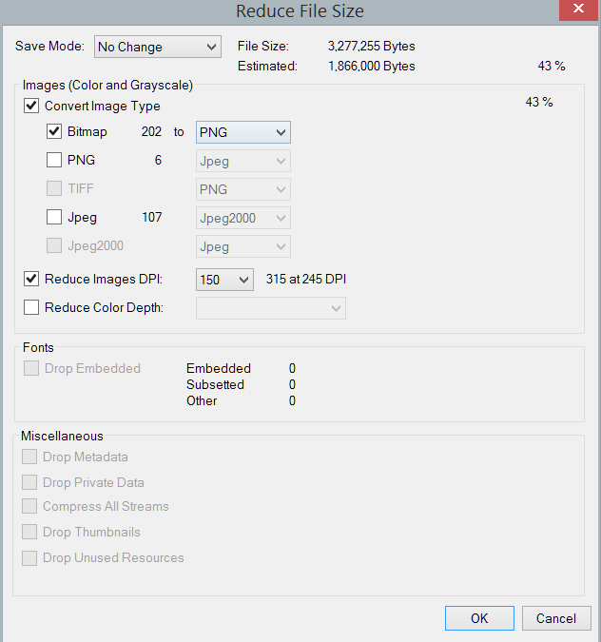

1. After pressing OK, Bluebeam will process the file and print it to a new document. Prompting you to save it at your desired location just as it did in above printing process. Once saved it will print the new file to the “Bluebeam Printer” and open the file. You may now use the new smaller file.